“Success: It Is Not Only for the Lucky” (Effective Speech Outline to Accompany Training DVD)

Success: It’s Not Just for the Lucky


EXCITE

How many of you want to achieve your goals in life successfully?

Me too.

LAUNCH

1. We can adopt certain strategies to help us to be successful.

2. I am going to share with you three success strategies that can help you to achieve your goals successfully.

3. The three success strategies I am going to share with you are the importance of:

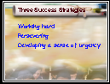

a. Working hard

b. Persevering

c. Developing a sense of urgency
Copyright: Dr. Marilyn Cristiano (with author’s permission, for use at PVCC)

RELATE



Since we all have set goals, it seems fitting to stop for a moment and reflect on some strategies we can use to successfully achieve our goals.

MAIN POINTS

1. Working hard



a. When we are successful, is it a matter of luck or hardwork?

b. Earl Wilson said, “Success is simply a matter of luck. Ask any failure.”

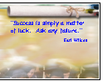

Copyright: Dr. Marilyn Cristiano (with author’s permission, for use at PVCC)
c. Click on next side.

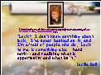

(1) Who was that?

(2) Would you say that Lucille Ball was a successful person?

(3) Lucy said, ““Luck? I don’t know anything about luck. I’ve never banked on it, and I’m afraid of people who do. Luck to me is something else: hard work--and realizing what is opportunity and what isn’t.”

(4) So it seems that as someone said:

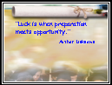

“Luck is when preparation meets opportunity.”

The idea that it is important to be prepared through hard work, so that when an opportunity presents itself, you will be able to take advantage of it.

Copyright: Dr. Marilyn Cristiano (with author’s permission, for use at PVCC)
2. Persevering



a. Would you say that Conrad Hilton was a successful person?

b. Conrad Hilton said, ““Success seems to be connected with action. Successful people keep moving. They make mistakes, but they don’t quit.”

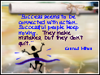

c. Show Kedra Holland-Corn Video



Copyright: Dr. Marilyn Cristiano (with author’s permission, for use at PVCC)
3. Developing a sense of urgency



a. Ed Bliss a time management expert said,



“You’ll never accomplish your goals until you realize that someday is not a day of the week.”

b. Do not put off until tomorrow what you can do today!



c. In order to this, you need to be good at delaying gratification.

(1) What does it mean to delay gratification?


Copyright: Dr. Marilyn Cristiano (with author’s permission, for use at PVCC)
(2) “Sacrifice is giving up something good for something better.”



(3) You can pay now and play later, or you can play now and pay later.



REITERATE

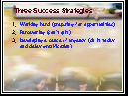

1. There are strategies we can adopt to help us to achieve our goals in life successfully.

2. I discussed three success strategies:

a. Working hard (preparing for opportunities)

b. Persevering (can’t quit)

c. Developing a sense of urgency (do it today and delay gratification)

Copyright: Dr. Marilyn Cristiano (with author’s permission, for use at PVCC)
ENERGIZE

1. Dennis T. Jaffee and Cynthia D. Scott in their book, Take This Job and Love it, write:

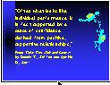
“Often what looks like individual performance is in fact supported by a sense of confidence derived from positive, supportive relationships.”

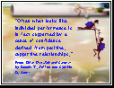

2. Since we all want to be successful, let’s all help each other to achieve our goals! I wish you all great success!

3. Thank you!

